
DATA ANALYTICS BOOT CAMP
By
Anshul Ojha Sir
APIS in Action Class Notes Report
On
BUILD A VIDEO UPLOAD API USING NODE.JS, EXPRESS & MONGODB
Submitted in partial fulfillment of the requirements for the Boot camp Certification
Bachelor of Technology
In
Computer Science and Engineering – Data Science
Of
Garden City University

By
Shravani S
Under the guidance of Anshul Ojha Sir (Bootcamp mentor).

DEV TOWN PROJECT:
APIS IN ACTION BOOTCAMP REPORT :
Project Title:
Build a Video Upload API using Node.js, Express & MongoDB
Project Description
This project focuses on creating a backend REST API using Node.js, Express.js, and MongoDB. The API is designed to allow users to add, retrieve, update, and delete video records.
Through this assignment, the following critical backend development concepts were implemented:
- Express routing
- Mongoose Schema design
- Request body validation
- CRUD API endpoints
- JSON response handling
- MongoDB Atlas Cloud Database connection
This project forms a strong foundation of building real-world backend applications.

Project Objectives
- Learn backend server setup with Express
- Store and retrieve data from MongoDB
- Implement validation rules & HTTP status codes properly
- Build REST API endpoints & test using Postman/Thunder Client

Technologies Used

Technology | Purpose
Node.js | JavaScript runtime to build server
Express.js | Web framework for handling APIs
MongoDB Atlas | Cloud NoSQL Database
Mongoose ODM | Connect & manage database
Body-Parser | Parse JSON requests
Nodemon | Auto-restart server during development
Thunder Client / Postman | API testing tool

Folder Structure

video-upload-api/
├─ server.js
├─ package.json
├─ .env
├─ routes/
│ └─ videos.js
├─ models/
│ └─ Video.js
└─ README.md

MongoDB Schema Design

Field | Type | Required | Purpose
title | String | ✅ Yes | Video title
description | String | ❌ No | Short summary
videoUrl | String | ✅ Yes | URL of uploaded video
createdAt | Date | ❌ No | Timestamp (default: now)
Schema is created using Mongoose for data validation and structure.

API Endpoints Implemented

Method | Endpoint | Description | Status Code
POST | /api/videos | Add a new video | 201
GET | /api/videos | Fetch all videos | 200
PUT | /api/videos/:id | Update video (Bonus) | 200
DELETE | /api/videos/:id | Remove video (Bonus) | 200

POST /api/videos — Request Example
{
"title": "JavaScript Basics",
"videoUrl": "https://youtube.com/example",
"description": "Learning JS fundamentals"
}

Success Response (201 Created)
{
"success": true,
"message": "Video added successfully!",
"data": {
"_id": "6508f912c8e4c4a1e17b49b2",
"title": "JavaScript Basics",
"description": "Learning JS fundamentals",
"createdAt": "2025-10-28T14:00:00Z"
}
}

GET /api/videos — Response Example
{
"success": true,
"data": [
{
"_id": "6508f912c8e4c4a1e17b49b2",
"title": "JavaScript Basics",
"description": "Learning JS fundamentals",
"createdAt": "2025-10-28T14:00:00Z"
}
]}

Validation Rules

Condition | Status Code | Message
title missing | 400 Bad Request | "title and videoUrl are required"
videoUrl missing | 400 Bad Request | Same as above
Internal server error | 500 | "Server error"
Proper error handling is implemented in each route.

API Testing
- Tested using Thunder Client
- JSON format requests
- Verified success & error cases
- All CRUD operations working
REFERENCE SCREENSHOTS:
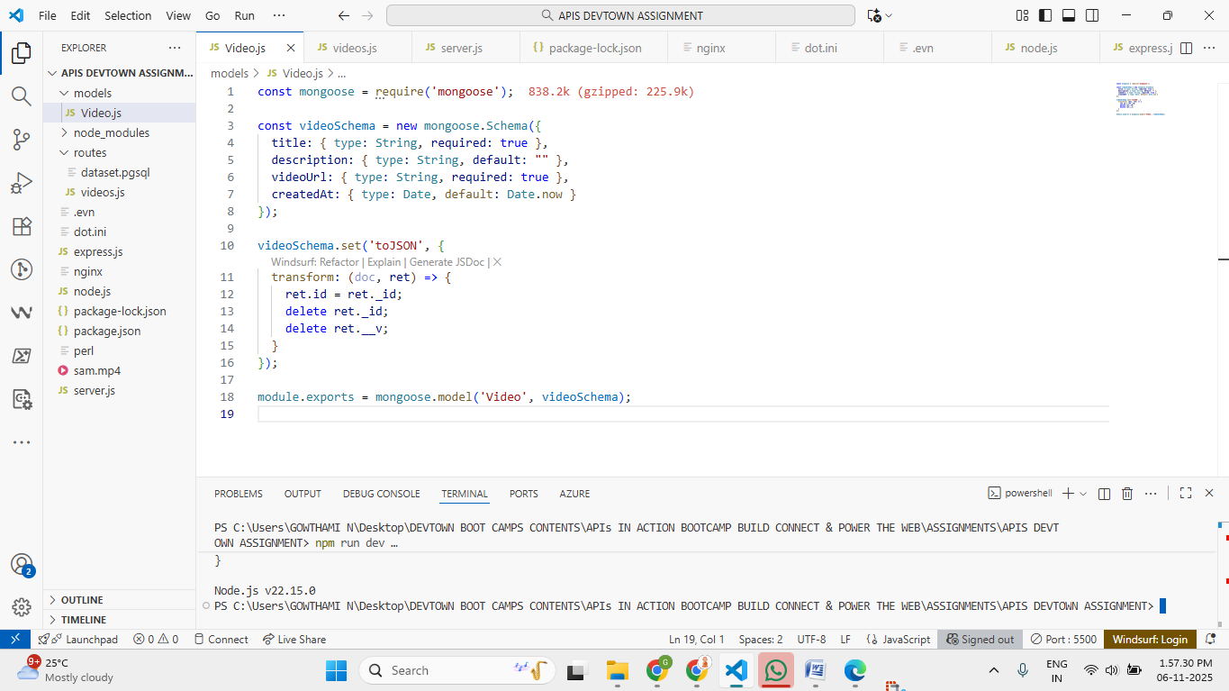
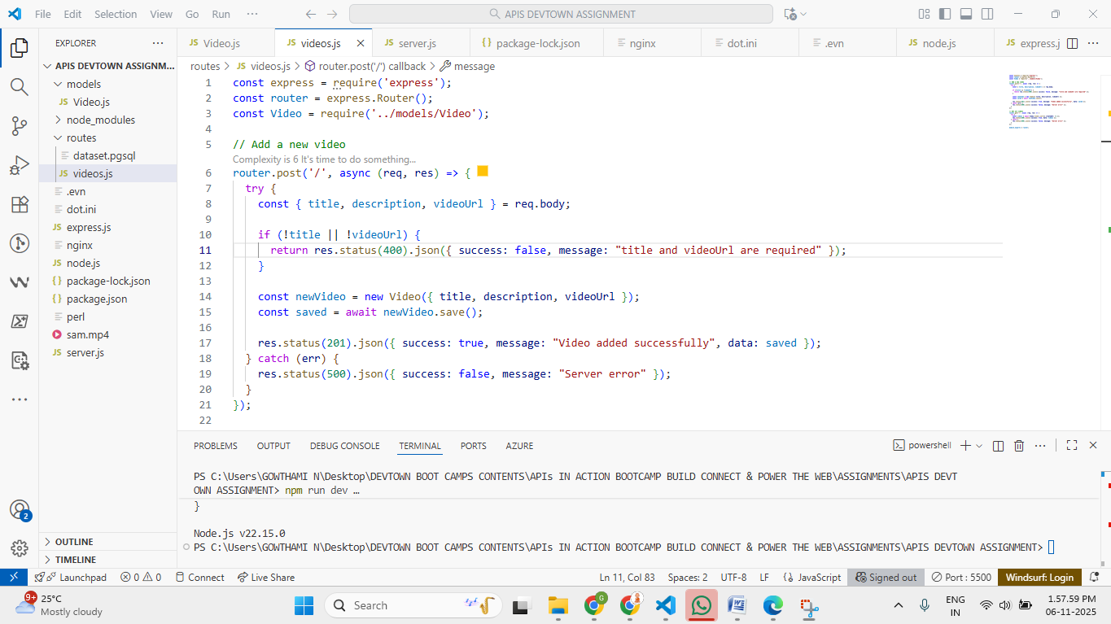
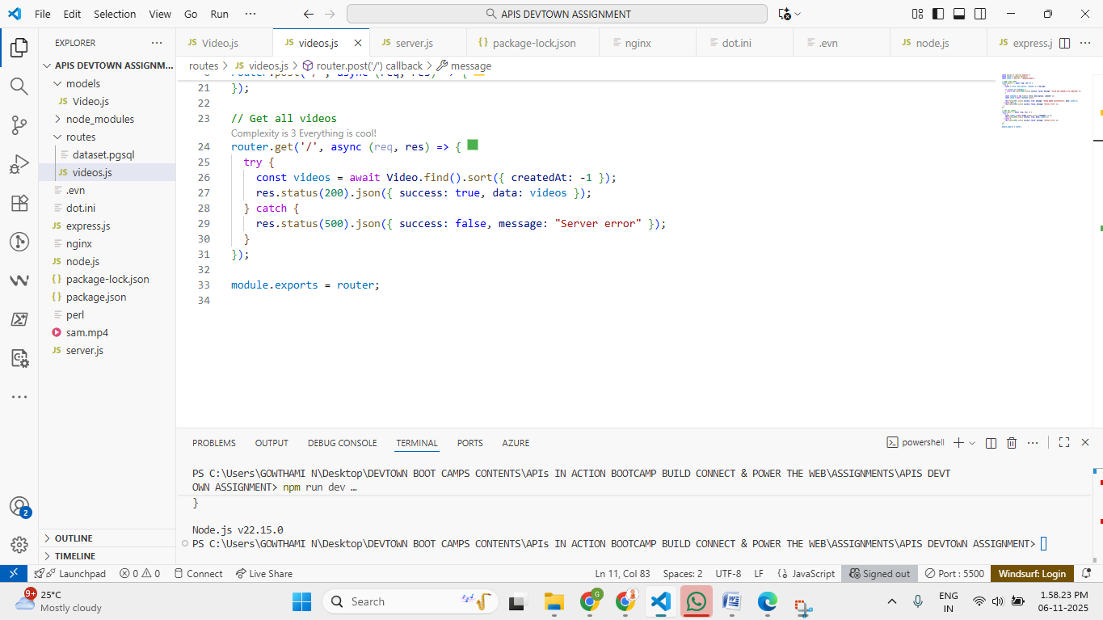
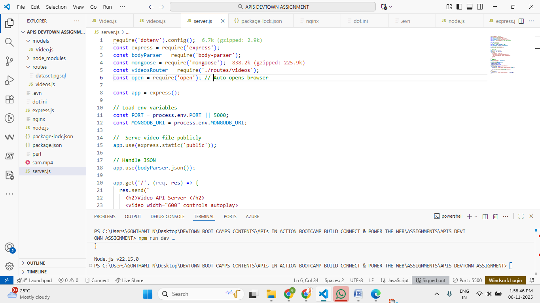
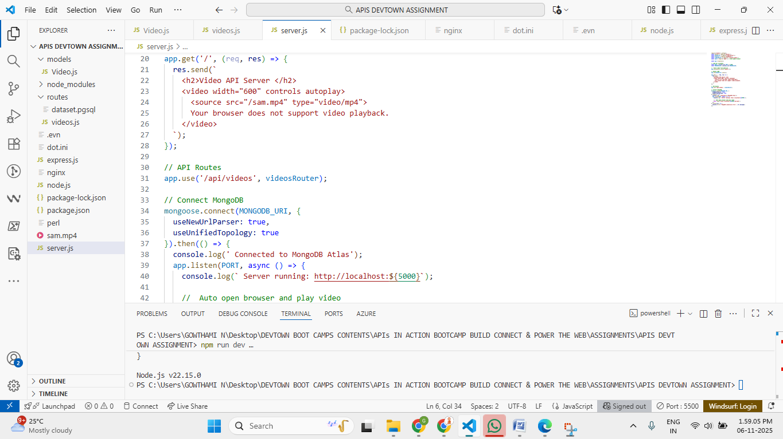
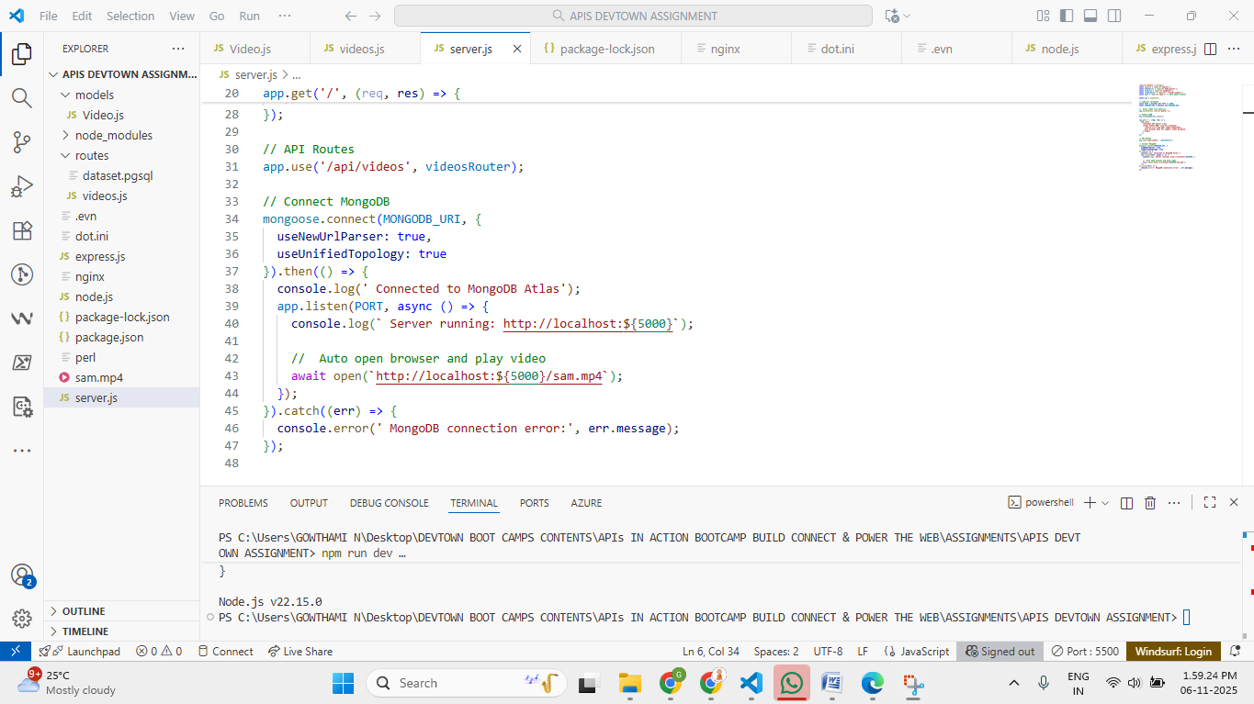
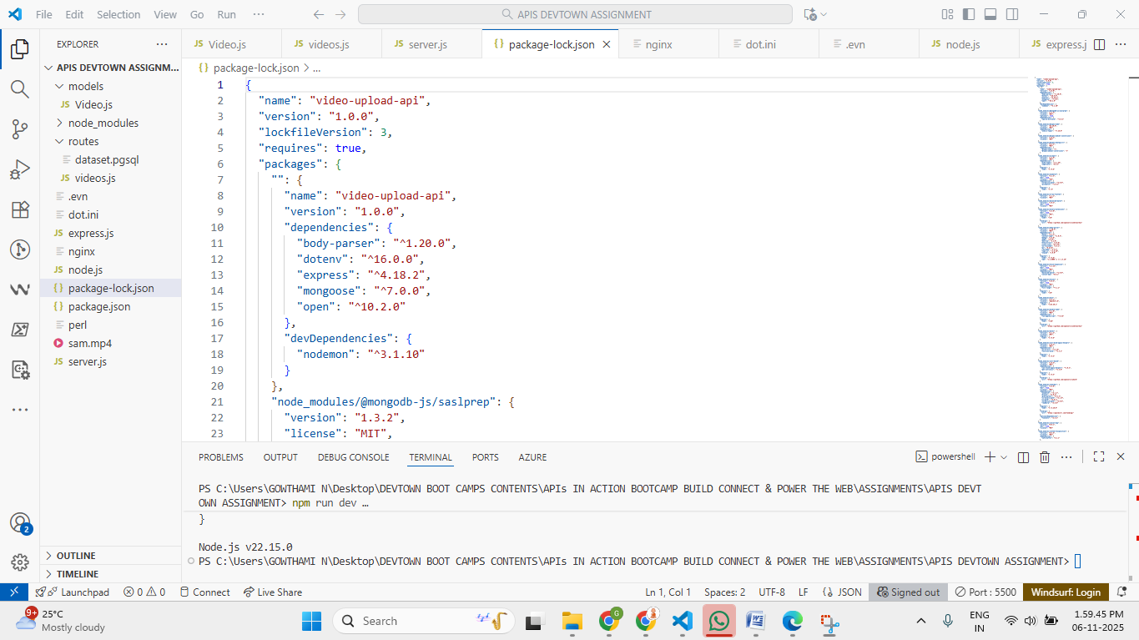
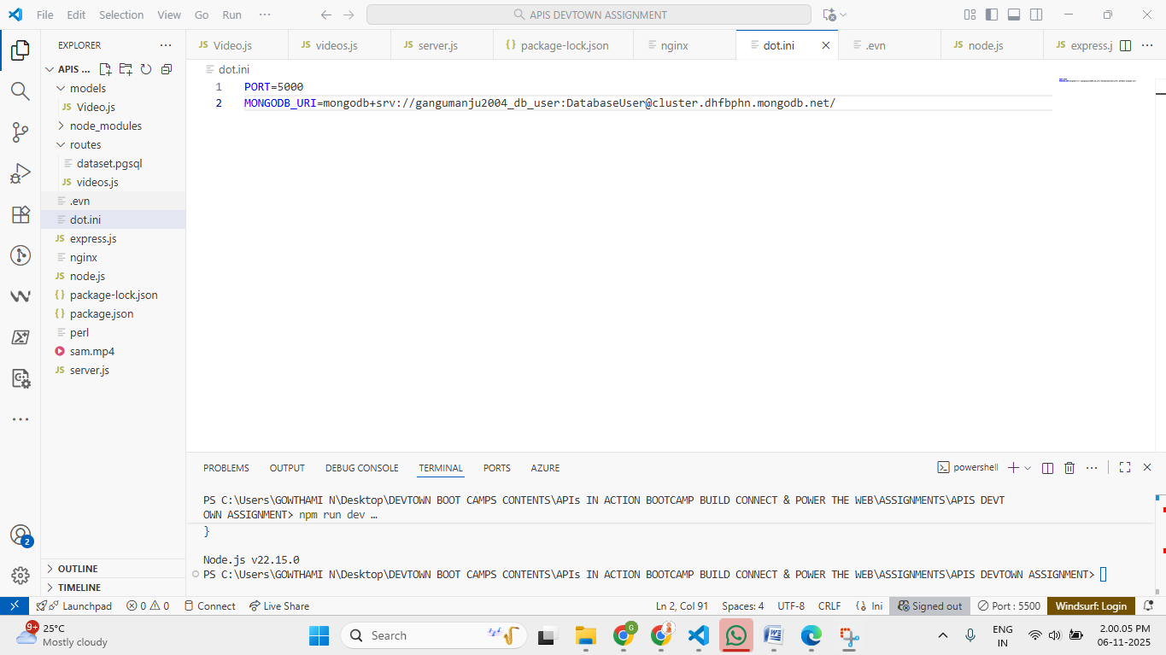
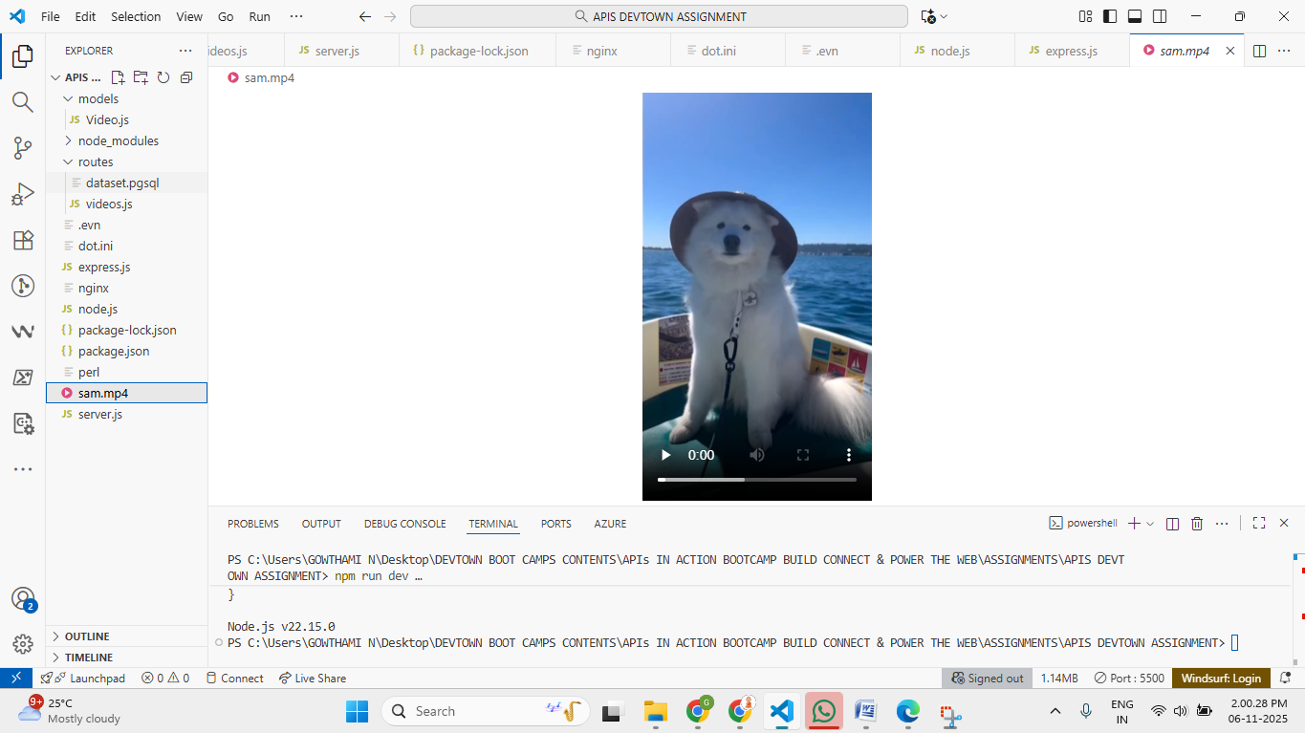
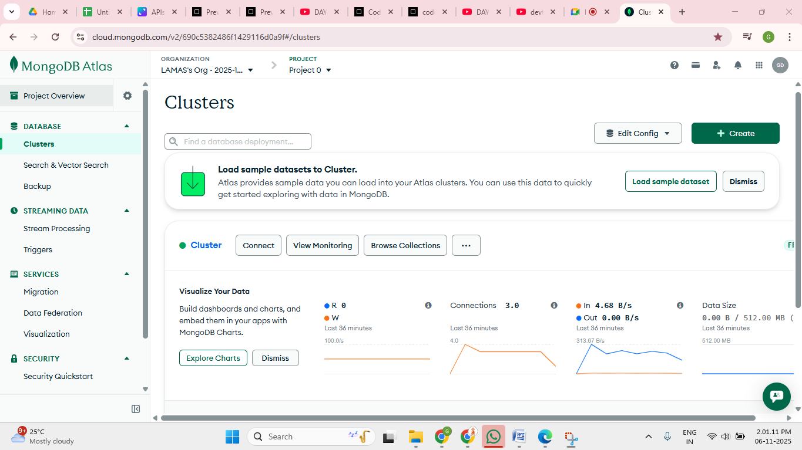
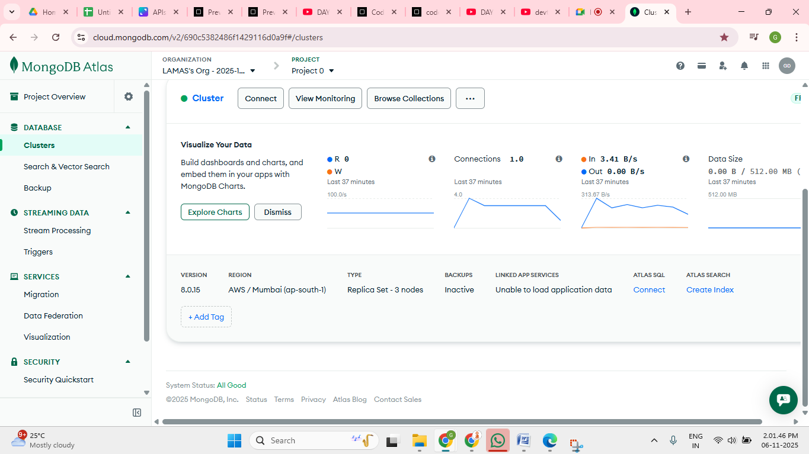
OUTPUT VEDIO SCREENSHOT:
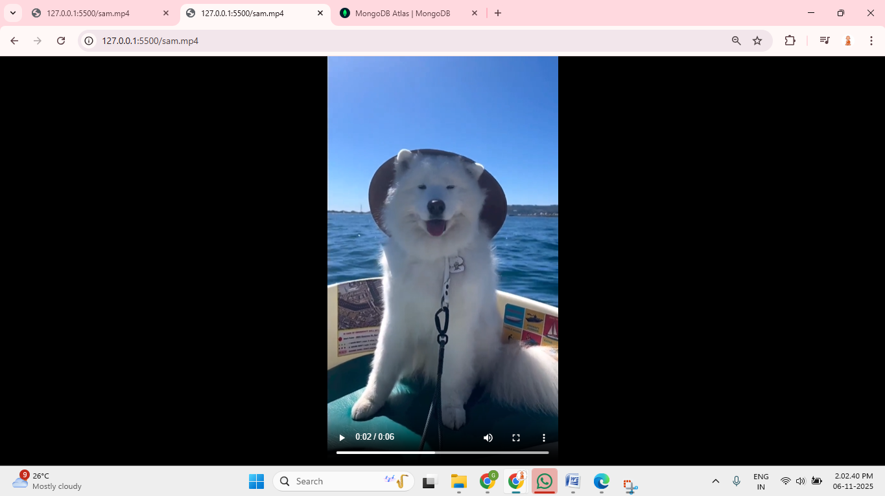

Conclusion
This project provided hands-on experience in developing a complete backend API using Node.js and Express.js along with MongoDB for database storage. It helped understand how real-world APIs are structured, validated, and deployed.
This assignment successfully covers all required concepts taught in the APIs in Action Bootcamp.

References
- https://expressjs.com/
- https://mongoosejs.com/
- https://nodejs.org/
- DevTown Bootcamp Content
NOTE:
Thank you Anshul Ojha Sir for the insightful APIs in Action Bootcamp. Your valuable guidance and clear teaching enhanced my backend development skills. I sincerely appreciate your support and dedicated efforts throughout the bootcamp.

